# TFT 터치패널 – 숫자판

## 목표

2.4인치 TFT 터치패널의 숫자판 구현 및 활용

## 회로도

## 실물

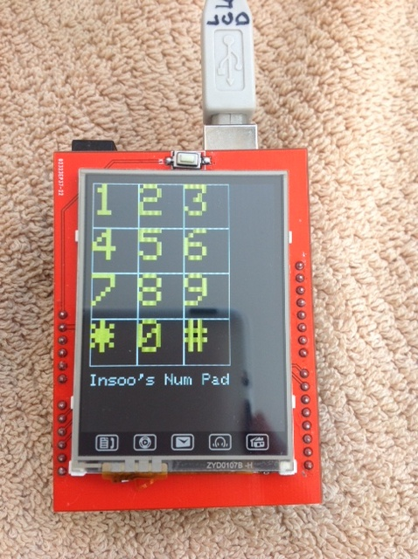

## 코드

#include "TFTLCD.h"

#include "TouchScreen.h"

//Duemilanove/Diecimila/UNO/etc ('168 and '328 chips) microcontoller:

#define YP A1 // must be an analog pin, use "An" notation!

#define XM A2 // must be an analog pin, use "An" notation!

#define YM 7 // can be a digital pin

#define XP 6 // can be a digital pin

//#define TS_MINX 150

#define TS_MINX 110

//#define TS_MINY 120

#define TS_MINY 200

#define TS_MAXX 920

//#define TS_MAXY 940

#define TS_MAXY 890

#define MINPRESSURE 10

#define MAXPRESSURE 1000

// For better pressure precision, we need to know the resistance

// between X+ and X- Use any multimeter to read it

// For the one we're using, its 300 ohms across the X plate

//TouchScreen ts = TouchScreen(XP, YP, XM, YM, 300);

TouchScreen ts = TouchScreen(XP, YP, XM, YM, 150);

#define LCD_CS A3

#define LCD_CD A2

#define LCD_WR A1

#define LCD_RD A0

// optional

#define LCD_RESET A4

// Color definitions

#define BLACK 0x0000

#define BLUE 0x001F

#define RED 0xF800

#define GREEN 0x07E0

#define CYAN 0x07FF

#define MAGENTA 0xF81F

#define YELLOW 0xFFE0

#define WHITE 0xFFFF

TFTLCD tft(LCD_CS, LCD_CD, LCD_WR, LCD_RD, LCD_RESET);

#define BOXSIZE 60

void setup(void) {

int i, k;

Serial.begin(9600);

Serial.println("Number Pad!");

tft.reset();

tft.initDisplay();

tft.fillScreen(BLACK);

//Number pad

for (i=0; i<3; i++)

for (k=0; k<4; k++)

{

tft.drawRect(BOXSIZE*i, BOXSIZE*k, BOXSIZE, BOXSIZE, WHITE);

if (k < 3)

tft.drawChar(BOXSIZE*i, BOXSIZE*k, (char)(49 + (k*3)+i), YELLOW, 6);

else

if (i == 0)

tft.drawChar(BOXSIZE*i, BOXSIZE*k, (char)(42), YELLOW, 6);

else if (i == 1)

tft.drawChar(BOXSIZE*i, BOXSIZE*k, (char)(48), YELLOW, 6);

else

tft.drawChar(BOXSIZE*i, BOXSIZE*k, (char)(35), YELLOW, 6);

} // for i, k

tft.drawString(BOXSIZE*0, BOXSIZE*4 + 10, "Insoo's Num Pad", WHITE, 2);

} // setup

void loop()

{

int i;

Point p = ts.getPoint();

p.x = map(p.x, TS_MINX, TS_MAXX, 0, tft.width());

p.y = map(p.y, TS_MINY, TS_MAXY, 0, tft.height());

if ((p.x > 200) && (p.x < 240))

{

if (p.y > 240)

{

Serial.println("1");

tft.drawString(40, 240, "One", YELLOW, 3);

//digitalWrite(0, HIGH);

//tft.drawVerticalLine (0, 15, 100, YELLOW);

}

else if (p.y > 160)

Serial.println("2");

else if (p.y > 80)

Serial.println("3");

else

Serial.println("1?");

} // if ((p.x > 200) && (p.x < 240))

else if (p.x > 160)

{

if (p.y > 240)

{

Serial.println("4");

//tft.drawString(20, 10, "Home", YELLOW, 3);

//tft.drawVerticalLine (0, 15, 100, YELLOW);

}

else if (p.y > 160)

Serial.println("5");

else if (p.y > 80)

Serial.println("6");

else

Serial.println("2?");

} // else if (p.x > 160)

else if (p.x > 120)

{

if (p.y > 240)

Serial.println("7");

else if (p.y > 160)

Serial.println("8");

else if (p.y > 80)

Serial.println("9");

else

Serial.println("3?");

} // else if (p.x > 120)

else if (p.x > 80)

{

if (p.y > 240)

Serial.println("*");

else if (p.y > 160)

{

Serial.println("0");

//digitalWrite(0, LOW);

}

else if (p.y > 80)

Serial.println("#");

else

Serial.println("4?");

} // else if (p.x > 80)

// Check printed icons on LCD

if ((p.x > -10) && (p.x < 15))

{

if (p.y < 30)

{

Serial.println("Home");

tft.drawString(20, 10, "Home", YELLOW, 3);

tft.drawVerticalLine (0, 15, 100, YELLOW);

}

else if (p.y < 100)

Serial.println("Headphone");

else if (p.y < 180)

Serial.println("Mail");

else if (p.y < 250)

Serial.println("Disc");

else if (p.y < 320)

Serial.println("Address");

} // if ((p.x > -10) && (p.x < 15))

// Don't know why put these statement as of Dec11,2014

// To be tested

pinMode(XM, OUTPUT);

pinMode(YP, OUTPUT);

pinMode(YM, OUTPUT);

delay(500);

} // loop

## 결과

터치패널에 생성된 숫자판의 숫자 키를 누르면 아래와 같이 시리얼 모니터에 표시된다. TFT LCD화면에 표시하는 것은 setup()에서는 가능하나, loop()에서는 되지 않는데, 2014.12.11 현재 아직 이유를 모른다.

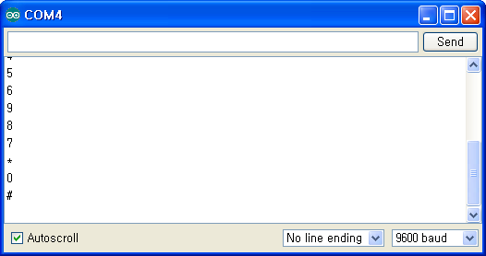

# 용어

# 참조

## Ebay 구매 사이트

<http://www.ebay.com/itm/131231342388?_trksid=p2060778.m2749.l2649&ssPageName=STRK%3AMEBIDX%3AIT> (2014.12.11 접근, 2014.11.13 주문)

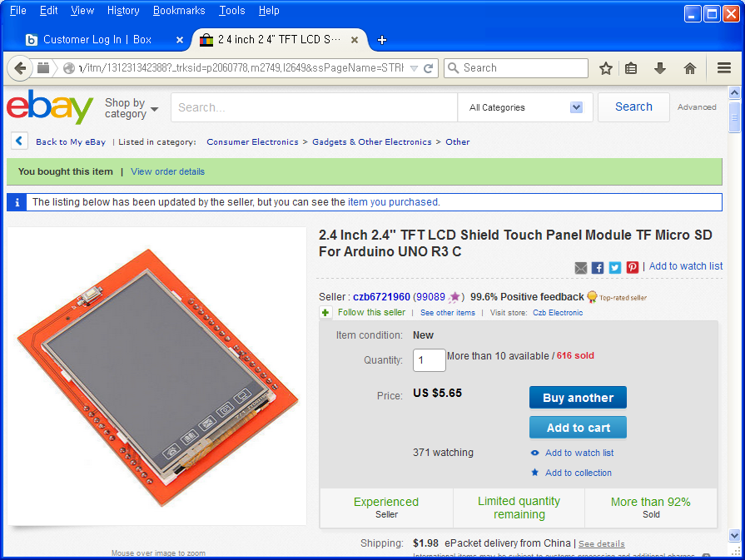

2.4" diagonal LCD TFT display

Bright, 4 white-LED backlight, on by default but you can connect the transistor to a digital pin for backlight control

Colorful, 18-bit 262,000 different shades

4-wire resistive touchscreen

spfd5408 controller with built in video RAM buffer

8 bit digital interface, plus 4 control lines

Uses digital pins 5-13 and analog 0-3. That means you can use digital pins 2, 3 and analog 4 and 5. Pin 12 is available if not using the micro SD

5V compatible, use with 3.3V or 5V logic

Package Included:

1PCS*2.4 Inch 2.4" TFT LCD Shield Touch Panel Module TF Micro SD For Arduino UNO R3 C

## 사용법

<http://misc.ws/2013/11/08/touch-screen-shield-for-arduino-uno/>